Multiple Linear Regression Model.

- In simple linear regression model, while using the Ordinary Least Squares method, the following situation is impossible
- high R-square while one of the coefficient is insignificant;
- low R-square while some of the coefficients are significant;
- high R-square while all of the coefficient are insignificant;
- low R-square while all of the coefficients are significant;
- all of the above is possible.

- A researcher has observed data on three economic variables, Y, 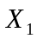 and 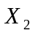 for a sample which could be divided into two subsamples. The researcher fits the regression of Y on and , with an intercept, for the whole sample (a), and for two subsamples (b and c), the residual sums of squares are equal to 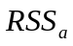, 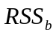 and 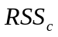 respectively. Which of the following statements is correct?
- 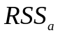 can be greater, less or equal to 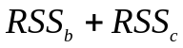,
- 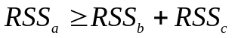,
- 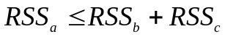,
- 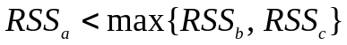,
- 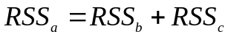.

- Introduction of three linear restrictions on parameters in a regression model, estimated using OLS
- results in minor increase of the sum of squares of residuals if at least one of the restrictions is valid;
- results in significant increase of the sum of squares of residuals only if all three restrictions are invalid;
- results in minor increase of the sum of squares of residuals if all three restrictions are valid;
- results in significant increase of the sum of squares of residuals if all three restrictions are valid;
- all the above is incorrect.

- In the multiple linear regression model with two explanatory variables 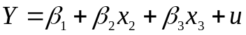 the OLS estimator of coefficient β₂, for a given sample, does not depend on:
- true value of intercept;
- observed values of 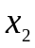;
- observed values of 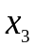;
- observed values of Y;
- sample covariance between and Y.

- Adding of an explanatory variable to linear regression model, estimated by OLS,
- always results in reduction of F-statistic;
- always results in increase of F-statistic;
- does not change F-statistic in the model;
- can increase or reduce the value of F-statistic in the model;
- never results in reduction of F-statistic.

- A researcher has observed data of three economic variables, y, x₁ and x₂, and he considers three hypothesises: (a) y depends on x₁ and x₂, (b) y depends only on x₁, and (c) y depends only on x₂. After the estimation of these three models, the values of RSS were equal to RSS_{a}, RSS_{b} and RSS_{c} respectively. Which of the following statements is correct?
1) RSS_{a} < RSS_{b} + RSS_{c},
2) RSS_{a} > RSS_{b} + RSS_{c},
3) RSS_{a} = RSS_{b} + RSS_{c},
4) RSS_{a} = RSS_{b} - RSS_{c},
5) RSS_{a} can be greater or less than RSS_{b} + RSS_{c}.

- In multiple linear regression model, high correlation between two explanatory variables results in:
- equality to zero of coefficients fitted by the Ordinary Least Squares.
- larger variance of coefficients fitted by the Ordinary Least Squares.
- biasedness of coefficients fitted by the Ordinary Least Squares.
- inefficiency of coefficients fitted by the Ordinary Least Squares.
- inconsistency of coefficients fitted by the Ordinary Least Squares.

- An OLS estimator of multiple linear regression slope coefficient 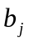 is the less reliable (i.e. its standard error is the larger), ceteris paribus, the
- greater is the mean squared value of 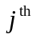 explanatory variable 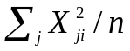;
- less is the determination coefficient of regression of 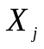 on all other Xs;
- greater is the sample size;
- greater is the sum of squared deviations of 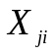 from the sample mean 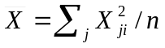.
- greater is the squared standard error of regression 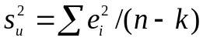;

- In a Multiple Linear Regression model with two explanatory variables, 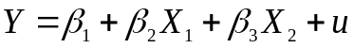, the explanatory variable was excluded. After that, the squared standard error of OLS regression (estimated on the same sample)
- has increased;
- has decreased;
- could increase, decrease or stay unchanged.
- could increase or stay unchanged, but not decrease;
- could decrease or stay unchanged, but not increase;

- A researcher has observed data of three economic variables, y, 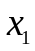 and , and he considers three hypotheses: (a) y depends on and , (b) y depends only on and (c) y depends only on . After the estimation of these three models, the values of 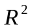 were equal to 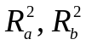 and 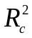 respectively. Which of the following statements is correct?
- 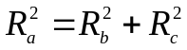,
- 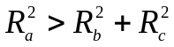,
- 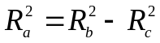,
- 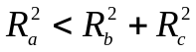,
- 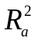 can be greater or less than 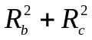.

Multiple Linear Regression Model.

- In simple linear regression model, while using the Ordinary Least Squares method, the following situation is impossible
- high R-square while one of the coefficient is insignificant;
- low R-square while some of the coefficients are significant;
- high R-square while all of the coefficient are insignificant;
- low R-square while all of the coefficients are significant;
- all of the above is possible.

- A researcher has observed data on three economic variables, Y, and for a sample which could be divided into two subsamples. The researcher fits the regression of Y on and , with an intercept, for the whole sample (a), and for two subsamples (b and c), the residual sums of squares are equal to , and respectively. Which of the following statements is correct?
- can be greater, less or equal to ,
- ,
- ,
- ,
- .

- Introduction of three linear restrictions on parameters in a regression model, estimated using OLS
- results in minor increase of the sum of squares of residuals if at least one of the restrictions is valid;
- results in significant increase of the sum of squares of residuals only if all three restrictions are invalid;
- results in minor increase of the sum of squares of residuals if all three restrictions are valid;
- results in significant increase of the sum of squares of residuals if all three restrictions are valid;
- all the above is incorrect.

- In the multiple linear regression model with two explanatory variables the OLS estimator of coefficient β₂, for a given sample, does not depend on:
- observed values of ;
- observed values of ;
- observed values of Y;
- true value of intercept;
- sample covariance between and Y.

- Adding of an explanatory variable to linear regression model, estimated by OLS,
- always results in reduction of F-statistic;
- always results in increase of F-statistic;
- does not change F-statistic in the model;
- can increase or reduce the value of F-statistic in the model;
- never results in reduction of F-statistic.

- A researcher has observed data of three economic variables, y, x₁ and x₂, and he considers three hypothesises: (a) y depends on x₁ and x₂, (b) y depends only on x₁, and (c) y depends only on x₂. After the estimation of these three models, the values of RSS were equal to RSS_{a}, RSS_{b} and RSS_{c} respectively. Which of the following statements is correct?
1) RSS_{a} < RSS_{b} + RSS_{c},
2) RSS_{a} > RSS_{b} + RSS_{c},
3) RSS_{a} = RSS_{b} + RSS_{c},
4) RSS_{a} = RSS_{b} - RSS_{c},
5) RSS_{a} can be greater or less than RSS_{b} + RSS_{c}.

- In multiple linear regression model, high correlation between two explanatory variables results in:
- equality to zero of coefficients fitted by the Ordinary Least Squares.
- larger variance of coefficients fitted by the Ordinary Least Squares.
- biasedness of coefficients fitted by the Ordinary Least Squares.
- inefficiency of coefficients fitted by the Ordinary Least Squares.
- inconsistency of coefficients fitted by the Ordinary Least Squares.

- An OLS estimator of multiple linear regression slope coefficient is the less reliable (i.e. its standard error is the larger), ceteris paribus, the
- greater is the mean squared value of explanatory variable ;
- less is the determination coefficient of regression of on all other Xs;
- greater is the sample size;
- greater is the sum of squared deviations of from the sample mean .
- greater is the squared standard error of regression ;

- In a Multiple Linear Regression model with two explanatory variables, , the explanatory variable was excluded. After that, the squared standard error of OLS regression (estimated on the same sample)
- has increased;
- has decreased;
- could increase, decrease or stay unchanged.
- could increase or stay unchanged, but not decrease;
- could decrease or stay unchanged, but not increase;

- A researcher has observed data of three economic variables, y, and , and he considers three hypotheses: (a) y depends on and , (b) y depends only on and (c) y depends only on . After the estimation of these three models, the values of were equal to and respectively. Which of the following statements is correct?
- ,
- ,
- ,
- ,
- can be greater or less than .

